**26 Sept 2014** **The Weekly Bulletin of Rotary Club of Kathmandu Mid-Town** **bc-13/9.014**

|  |
| --- |
|  |

District: 3292 Web:www.rotarymidtown.org.np Club Id: 26776

**SEPTEMBER IS NEW GENERATIONS MONTH**

**Celebrating**

**25 Years in Rotary**





Friday, 19 September : Extracts of the Meeting Minutes # 1247

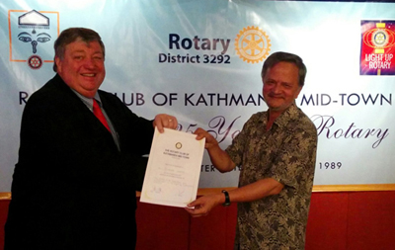

Acting President Peter handing over a

certificate of appreciation to Guest Speaker Dr Pitambar Sharma.

“ Acting President Peter spoke briefly about the Guest Speaker Dr. Pitambar

Sharma. He emphasized the critical role of the Planning Commission and

how implementation has been the challenge in the context of Nepal.

“ Rtn Dr. Shankar Sharma introduced the Guest Speaker Sharma.

“ Dr. Pitambar Sharma spoke about the perspective on state restructuring –

name, number and delineation of the state, special structures, right to

self determination, political and development implications. The implications

of the ethnic/caste and linguistic mosaic of for the proposed restructuring of

the country under federal lines are that federal units, however conceived,

cannot but be multi-ethnic and multi-linguistic. Management and recognition

of minority identity, rights and opportunities, inclusive development, and

devolution of power to the lowest level are therefore the key concerns in addressing the question of ethnicity and federalism in Nepal.

“ PP Giridhar, Rtn Sanjib & Rtn Govinda took part in the discussion.

“ Rtn Govinda gave vote of thanks to Dr. Sharma.”

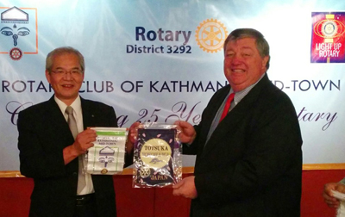

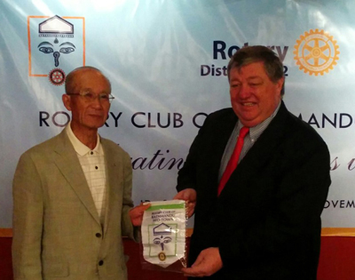

Actg President Peter

exchanging club

banner with visiting

Rotarians

Information Sharing:

- “ Acting. President Peter gave MPHF pin to PP Giridhar

- “ Rtn Paras informed that Rotary Club of Totsuka, Yokohama are interested to have discuss with our club for global grant project. They are already involved in Janata Primary School project.

- “ Rtn Govinda enquired about the Changa Chait Program to be held on Sept 26 at Rtn Navyo’s place.

- “ Members present: 22

- “ Visiting Rotarians: 6 “

# Weekly Meetings and Programs :

|  |  |  |
| --- | --- | --- |
| Date | Program/Speaker | Topic of Presentation |
| 26 September | Mr. Lalit Bikram Shah | Civil Aviation in Local and International Context |
|  |  |  |
|  |  |  |
|  |  |  |

Friday, 26 September :



Mr. Lalit Bikram Shah, a renowned name in Nepal Civil Aviation, will be our Guest Speaker. He will

give a talk on civil aviation in local and international context.

Lalit B Shah joined International Civil Aviation Organization as the Head of Asia and Pacific

Regional Office in Bangkok in January 1993. During his illustrious tenure of 15 years with ICAO

he served as the Secretary to the Regional Air Navigation Planning Group and was instrumental

in resolving several complex airspace issues and introducing major route structures of immense

benefits in the region. He is also credited with forging a very cohesive platform of the Asia/Pacific

Aviation Group and other cooperative Sub-Groups which have served as models in other parts of the region. He was retired from ICAO in Dec 2007.

Before that he joined Department of Civil Aviation, HMG/Nepal to take up career in Civil Aviation after having completed a study in Air Traffic Services in Regional Centre, Bangkok in 1964. Working his way up through various important positions, he was the Director General of Civil Aviation Department in 1986 up until the end of 1992 when he separated from the Government service. He had put in 28 years of service in civil aviation.

He did his Senior Cambridge from St. Xavier's school, Kathmandu and his Pre-University in Economics from St.Xavier's College Calcutta. He completed his Master's degree in English in 1969 from TU.

He attained his Private Pilot Licence from Oxford Flying School, England. His professional advancement includes various studies in Airspace Management,etc in Federal Aviation Academy, USA.

**ICM on Total Knee and Hip Replacement**

The presidents of two clubs: Rotary Club of Kathmandu West and Rotary Club of Tripureshwor invite all Rotarians to participte in the ICM on Total Knee and Hip Replacement. They write “as we grow older, the problems in our joints also increase. This ICM will give us an insight on these problems with an active participation from the experts, audience and patients who have had these problems and have been operated. Our District Governor Rtn. Rabindra Piya has kindly consented to be the Chief Guest. Seats will be limited, so kindly register early.”

Date: 27th September 2014, Saturday

Venue: Indreni Foodland, Baneswor

Time : 5:00 pm

Registration: Rs. 500/-

The event will be followed by dinner.

**Clean Up the World Weekend: (19-21 September)**



In addition to uniting millions in global environmental action, Clean-Up-the-World

Weekend serves as a celebration of participants’ year round activities. By promoting

their achievements internationally, Clean-Up-the-World focuses public attention on

global community concerns for the environment and how each individual can make

a positive contribution to a cleaner and healthier world.

Groups, organisations, schools and businesses from communities around the world

unite on Clean-Up-the-World Weekend to take action at a local level to address

global environmental issues.

Clean-Up-the-World encourages participants to organise an activity on or around

the Weekend and to celebrate their environmental successes achieved throughout

the year. Activities can include clean up’s, tree plantings or environmental awareness

raising activities.

The campaign theme “Our Place… Our Planet… Our Responsibility” highlights

how local action taken by every community and volunteer partaking in a Clean-Up-the-World activity has a global impact.

On the occasion of the Clean-up-the-World Weekend, Clean Up Nepal has undertaken a ‪Clean up Nepal 2014‬ Nationwide Cleanup where clean-ups were carried out at the same time at over 70 locations throughout Nepal between 7am and 11am. Embracing the slogan ‘Join the Green Revolution: Stop Neighbourhood Pollution’, more than 20,121 volunteers participated nationwide!

*Source: Internet News*

**International Day of Peace: 21 September**

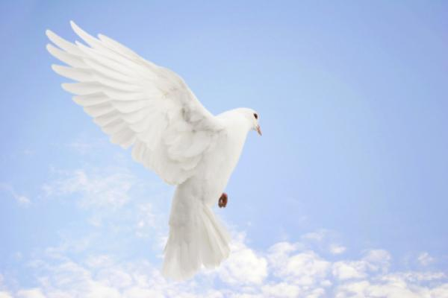

Each year the International Day of Peace is observed around the world on

21 September. The General Assembly has declared this as a day devoted

to strengthening the ideals of peace, both within and among all nations and

peoples.

To mark the 30th anniversary of the General Assembly Declaration on the

Right of Peoples to Peace the theme of this year’s International Day of

Peace is the “Right of Peoples to Peace”. This anniversary offers a unique

opportunity to reaffirm the United Nations commitment to the purposes and

principles upon which the Organization was founded. The Declaration on

the Right of Peoples to Peace recognizes that the promotion of peace is

vital for the full enjoyment of all human rights.

The International Day of Peace was established in 1981 by resolution 36/67 of the United



Nations General Assembly to coincide with its opening session, which was held annually

on the third Tuesday of September. The first Peace Day was observed in September

1982.

In 2001, the General Assembly by unanimous vote adopted resolution 55/282, which

established 21 September as an annual day of non-violence and cease-fire.

The United Nations invites all nations and people to honour a cessation of hostilities

during the Day, and to otherwise commemorate the Day through education and public

awareness on issues related to peace.

***“… We must douse the fires of extremism and tackle the root causes of conflict.***

***Peace is a long road that we must travel together – step by step,* beginning**

***today. Let us all reflect on peace – and what it means for our human family.***

***Let us hold it in our hearts and minds and tenderly nurture it so it may grow***

***and blossom.”***

- *Ban Ki-moon, UN General Secretary*

*Source: Internet News*

**Dashain : Ghatasthapana:** 25 September



Dashain is the biggest festival for the Hindus. Dashain

commemorates the victories of the gods and goddesses

over the demons. It symbolizes the victory of the good

over the evil.

The first nine days of Dashain symbolizes the battle

which took place between the different manifestations

of goddess Durga and the demon Mahishasura. The

tenth day is the day when Durga finally defeated

Mahishasura. Goddess Durga is worshipped throughout

the country as divine mother goddess.

The festival is important since it reminds everyone of

the universal principles of truth, justice and virtue that

must prevail over deception, injustice and wickedness.

Ghatasthapana, which lies on the first day of lunar bright fortnight, *Aswin sukla pachhya*, is the first day of the 15-day Dasain festival. On this day, all Hindu Nepalese households, in Nepal or elsewhere, start Dashain puja by sowing barley seeds in the Dashain-ghar (puja-room) for germinating seedlings, called *jamara*, to offer the almighty Goddess Durga Bhavani on the tenth day of Dashain, Vijaya Dashami. Starting from the day of Ghatasthapana nine different incarnations of Goddess Shakti are worshipped:

The first day: goddess Shailaputri, 2nd day : goddess Brahmacharini,

3rd day : goddess Chandraghanta, 4th day : goddess Kushmunda,

5th day : goddess Iskandamata, 6th day : goddess Katyani,

7th day : goddess Kalaratri, 8th day : goddess Mahagauri, and

9th day : goddess Siddhidatri

*Source: Internet News*

**Committee Chairs’ Column:** *(This column is for use by chairpersons of 5 permanent committees: Club Administration, Membership, Public Relations, Service Projects, and the Rotary Foundation)*

On Lighter Side :

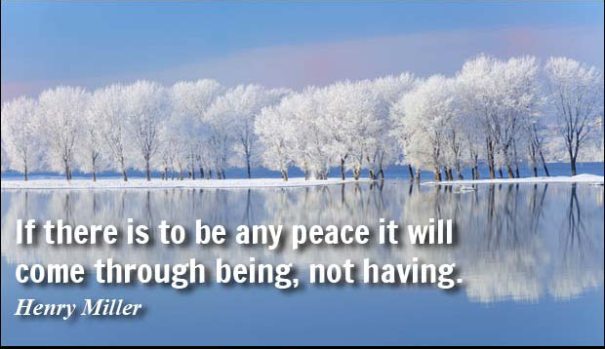

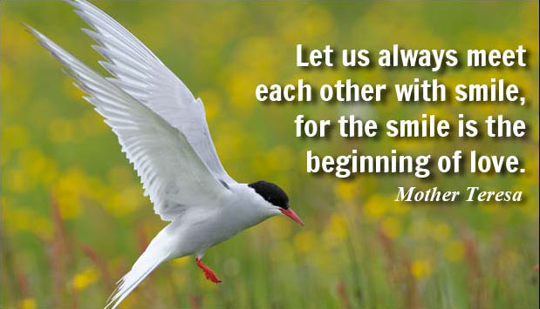

Great Quotes:

**[Forgiveness is not always easy.](http://www.brainyquote.com/quotes/quotes/m/mahatmagan107039.html" \o "view quote)**

**[At times, it feels more painful than the wound we suffered,](http://www.brainyquote.com/quotes/quotes/m/mahatmagan107039.html" \o "view quote)**

**[to forgive the one that inflicted it.](http://www.brainyquote.com/quotes/quotes/m/mahatmagan107039.html" \o "view quote)**

**[And yet, there is no peace without forgiveness.](http://www.brainyquote.com/quotes/quotes/m/mahatmagan107039.html" \o "view quote)**

- Marianne Williamson

**Members’ Corner:** *(This column is for Club members to express anything they would like in matter of Club activities, Club administration, Club issues or on Breakfast Chatter, or on anything else that would be of interest to fellow members.)*

**Wishing you all Mid-Towners a Very Happy Vijaya Dashami !**

**Let there be Peace everywhere – at home, at office, at work place, at neighbourhood,**

**in the community, in the region, in the country and in the world !!**

**Wishing Durga Bhavani bless ‘*tathastu’***

When I became a Rotarian, environmental issues were barely on our radar. To

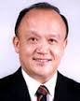

young people today, these concerns are front and center. Their perspective is a

valuable contribution to the world of Rotary service, and it is one that we should all

encourage and support. Just as they are learning from us, so should we be learning

from them..

**RI President GARY C.K. HUANG**

Please send information on club activities, progress reviews on service projects, relevant photos etc to:

BC Editor: RR Shrestha email: rryesrr@gmail.com

## 26 September 2014 The Weekly Bulletin of Rotary Club of Kathmandu Mid-Town bc-13/9.014